“The Lost Island” A
Short Film Animation

A Capstone Project Presented to the Faculty of the
College of Information Technology Education

PHINMA University of Iloilo

In Partial Fulfillment
of the Requirements for the degree Bachelor of Science in Information Technology

Group: “Fancy Tree” Members:
Laurence Quinto Elizabeth Labita

April 2026

Approval Sheet
In partial fulfillment of the requirements for the Bachelor of Science in Information Technology, this Capstone Project entitled “The Lost Island” prepared and submitted by Laurence Quinto and Elizabeth Labita. Who are hereby recommended for corresponding final evaluation.

Andrade, Jomanuel
Adviser

Approved by the Panel of Evaluators with a grade of PASSED

Dr. Arnold M. Fuentes, Ph. D, MPA, MMIT
Chairman

Ryan Valeriano
Member

Accepted in partial fulfillment of the requirements of the degree Bachelor of Science in Information Technology

Seth dA. Nono, MSCS
CITE, DEAN

Acknowledgement

First and foremost, we would like to express our deepest gratitude to Almighty God for His endless guidance, wisdom, and blessings throughout the duration of this capstone project. His grace gave us strength, creativity, and perseverance to complete our animation successfully.
We would also like to extend our sincere appreciation to our animation adviser, Mr. Jomanuel Andrade, for his constant support, valuable insights, and encouragement that guided us from pre-production to the completion of “The Lost Island.”
Our heartfelt thanks also go to the faculty members of the College of Information Technology Education, PHINMA University of Iloilo, for their advice, knowledge, and feedback that greatly helped us improve both technically and creatively.
To our classmates, peers, and friends, thank you for your cooperation, constructive comments, and moral support throughout the process of animation production.
We are especially grateful to our families for their unwavering love, patience, and understanding, which motivated us to keep going despite challenges and late-night work sessions.
Lastly, we thank all those who directly or indirectly contributed to the success of this project. Your encouragement and belief in our abilities have inspired us to bring our vision to life through animation.
Above all, we dedicate this accomplishment to God and to everyone who believes that creativity, teamwork, and perseverance can turn imagination into reality.

Abstract

Lost Island is an animated adventure packed with a unique and colorful art style inspired by Adventure Time. The story follows Urien and Qinn, two survivors of a shipwreck, as they discover the dangers of a mysterious island rumored to hide a legendary treasure. After their journey through the jungle and
betrayal from a villainous crew member, they discover the treasure but accidentally trigger a trap, sealing the treasure within the crumbling ruins.
Believing they have escaped with their lives, Urien and Qinn prepare to leave the island, but their journey takes an unexpected turn. A single gold coin they find from the sand turns into a giant golden monster. Forced into a desperate fight, they discover the creature's weakness and defeat it, unleashing a rain of coins that rains down on the island.
With their boat now loaded with treasure, Urien and Qinn sail away, forever changed by the adventure. Lost Island delivers an engaging narrative full of humor, action, and heartfelt moments, offering a thought-provoking exploration of greed, resilience, and the power of teamwork in a world visually appealing.

TABLE OF CONTENTS

Title Page —------------------------------------------------------ i
Approval Sheet —-------------------------------------------------- ii
Acknowledgement —------------------------------------------------- iii
Abstract —-------------------------------------------------------- iv
Table of Contents —----------------------------------------------- v-vi

CHAPTER I
Introduction —---------------------------------------------------- 7
Problem Statement ------—--------------------------------- 8
Objectives of the Study -—-------------------------------- 8
Significance of the Study —------------------------------- 9
Scope and Limitation —------------------------------------ 10

CHAPTER II
Related Literature —----------------------------------------------- 11-12
Reference ------------------------------------------------ 13

CHAPTER III
Description ------------------------------------------------------- 14
Research Methodology ------------------------------------- 14
Qualitative Research ------------------------------------- 14
Quantitative Research ------------------------------------ 15
Research Design ------------------------------------------ 15
Data Collection Methods ---------------------------------- 16-17
Data Analysis -------------------------------------------- 18
Collection Methods --------------------------------------- 19
Tools for Analysis --------------------------------------- 19-21
Project Management --------------------------------------- 22-23
Tangible and Intangible Benefits ------------------------- 23-24
Proposed Budget ------------------------------------------ 24
Return Of Investment ------------------------------------- 25-26
Breakdown Of ROI ----------------------------------------- 26-27

CHAPTER IV
Animation Content —--------------------------------------------- 28-31

Design and Genre of the Animation —---------------------- 32-33

Description of Every Character —------------------------- 34-37
Layout Scenes —------------------------------------------ 38-41
Post-Production, Challenges, and Target Audience -------- 42

CHAPTER V
Conclusion and Summary ----------------------------------------- 43-44
Bibliography —------------------------------------------------- 45
Appendix A: Survey Questions------------------------------ 46-47
Appendix B: Survey Responses ----------------------------- 47-51
Curriculum Vitae —---------------------------------------------- 52-54
Grammarian Certificate —----------------------------------------

List of Tables
Table Pages
2x2 Project Management 20-21

CHAPTER I

Introduction

In a world where imagination fuels adventure, The Lost Island brings to life an animated tale of survival, mystery, and wonder. Inspired by the art style of Adventure Time, this capstone project follows the journey of two shipwreck survivors, Urien and Qinn, as they uncover the secrets of a mythical island said to hold a legendary treasure. Blending elements of fantasy, friendship, and fate, the story takes viewers on a colorful and emotional voyage where every discovery leads to something unexpected.
The adventure begins when a fierce storm wrecks the explorers’ ship, leaving Urien and Qinn stranded on a mysterious island. Guided by a treasure map, they explore the lush landscape and uncover a hidden cave filled with glowing gold. However, their excitement turns to fear when a fellow crew member’s greed triggers a deadly trap, causing the cave to collapse and bury the treasure forever.
As the two survivors rest by the shore, they stumble upon a magical lamp buried in the sand. When Qinn wipes it clean, a swirl of blue smoke reveals a majestic genie who grants them one wish. Choosing home over riches, Urien and Qinn are safely returned to their village, only to find the same lamp mysteriously resting on their drawer, hinting that some treasures are meant to find their way back.
The Lost Island is more than a tale of adventure; it is a reflection on greed, destiny, and the true meaning of wealth. Through vibrant animation, heartfelt storytelling, and fantasy-driven visuals, this project reminds viewers that the greatest treasures are not made of gold but of courage, wisdom, and the bonds formed along the journey.

Problem Statement

In modern storytelling and animation, creating engaging stories that capture the audiences while conveying meaningful lessons remains a challenge. Many adventure-themed animations focus heavily on action and humor, often overlooking deeper emotional and moral dimensions. With the growing demand for stories that blend entertainment with substance, there is a need for creative projects that balance excitement, imagination, and heartfelt moments in a colorful way. The Lost Island aims to address this gap by presenting an animated story that explores themes of survival, greed, destiny, and the true meaning of wealth. Through fantasy storytelling and expressive animation, it captures both the thrill of adventure and the value of wisdom and friendship.

Objectives of the study

- To create an engaging animated story that combines fantasy, and adventure to the audience.
- To explore moral themes, including the consequences of greed, the power of choice, and the importance of cooperation.
- To design a visually colorful background inspired by the art style of Adventure Time.
- To highlight the power of storytelling in conveying meaningful lessons through creative and innovative animation.

Significance of the Study

This study’s main focus is the creative potential of animation as a tool for storytelling that entertains while conveying important life lessons. “Lost Island” serves as a case study in balancing visual appeal with meaningful narrative themes, making it meaningful for both creators and audiences.
For animators, the project demonstrates how to effectively use animation to inspire creative thinking, and engage audiences of different ages. For viewers, it delivers a story that combines excitement and reflection, offering lessons about the dangers of greed and the value of teamwork. In the end, this project contributes to the evolving landscape of animated storytelling, emphasizing creativity, innovation, and the timeless power of meaningful narratives.

Scope and Limitation

The Lost Island project will cover the constraints that define its boundaries. It established the creative focus of the project, detailing what aspects of the animated story would be prioritized, such as character development, visual storytelling, and thematic exploration. At the same time, it recognizes limitations, including time, resources, and technical feasibility, that restrict the scale of animation and the depth of certain narrative elements. By addressing both its scope and limitations, this section provides a clear framework for implementing the project while ensuring alignment with its goals.

Scope:

- The project focuses on producing an animated film of The Lost Island, including character designs, and environmental settings.
- The animation will emphasize storytelling through visual art, sound design, and character movements.
- The narrative explores the journey of two main characters, Urien and Qinn, within a confined setting of a mysterious island, featuring key themes of survival, and teamwork.
- The final output will be a short-animated film presentation showcasing important moments of the story.

Limitations:

- The project is done at a student level; it prioritizes narrative and style. The level of polish will be appropriate for its academic context rather than industry production.
- The art style is meant for simple cartoonish.
- The story mainly focuses on Urien and Qinn with less attention given to side characters to keep the project manageable.

CHAPTER II

Review of Related Literature

- Artistic Style & Storytelling in Animation

According to Karmakar (2021), more artistic styles have a profound influence on storytelling in animation, as visuals play a central role in conveying emotion and narrative depth to audiences. The study emphasizes that the choice of art style can significantly affect how viewers interpret and connect with the story. These findings align with broader research on the relationship between visual design and audience engagement, reinforcing the importance of adopting a vibrant, stylized approach such as the Adventure Time inspired background used in The Lost Island to enhance emotional resonance and narrative effectiveness. (pp.200-209)

Psychological Effects of Animation on Viewers

Research published in Wiley (2022) highlights the psychological impact of animation, showing that animated characters and motion effectively capture and sustain audience attention. According to this study, the integration of visuals with engaging narratives can create a more immersive viewer experience. Similarly, the pacing and visual energy in animated works are shown to contribute to long-term audience engagement. These findings support the creative approach of our capstone which combines animation with adventurous storytelling to maintain audience interest. (pp.1-14)

Animation as a Tool for Values Education

Yesiltaş and Kılıç (2021) examined the use of animation in values education and found that students exposed to animated lessons demonstrated higher levels of value investment compared to those taught using traditional methods. According to their study, animation encourages better retention and emotional connection to moral concepts. Moreover, the researchers found that animated storytelling can encourage empathy, cooperation, and ethical reflection key themes also explored in The Lost

Island, particularly in its narrative focus on teamwork, resilience, and forgiveness. (pp.1370-1387)

Digital Storytelling & Student Engagement

Lazareva and Cruz-Martinez (2020) investigated collaborative digital storytelling and found that it promotes creativity, reduces stress, and enhances engagement through structured narrative progression and feedback. These findings align with broader research on the role of structured storytelling in sustaining audience investment. Similarly, their emphasis on narrative pacing and emotional buildup directly informs The Lost Island’s approach to structuring its plot for maximum viewer engagement. (pp.383-406)

References

Karmakar, A. (2021). Investigation of artistic styles for effective storytelling in animation. NVEO: Natural Volatiles & Essential Oils, 8(3), pp. 200–209. ISSN:2148-9655.
Psychological Impact and Influence of Animation on Viewer’s Visual Attention. (2022). Journal of Electrical and Computer Engineering, 2022, pp. 1–14. Article ID 8802542. 10.1155/2022/8802542
Kılıç, E., & Yesiltaş, E. (2021). Effectiveness of values education with animations in social studies teaching.
International Online Journal of Educational Sciences, 13(5), pp. 1370–1387. ISSN:1309-2707
Lazareva, A., & Cruz-Martinez, G. (2020). Digital storytelling project as a way to engage students in twenty-first century skills learning. International Studies Perspectives, 22(4), pp. 383–406. 10.1093/isp/ekaa017

CHAPTER III

Research Description

This study focuses on the creation of The Lost Island, an animated short film that tells the story of two shipwreck survivors, Urien and Qinn, as they find a mysterious island rumored to hold a legendary treasure. The project is inspired by the art style of Adventure Time and aims to deliver a compelling narrative that balances entertainment with deeper thematic messages.
Research includes examining various aspects of animation production, including character design, visual storytelling, and audience interaction. By using animation principles and storytelling techniques, this study aims to contribute to the field of digital animation and interactive media.

Research Methodology

This study uses a mixed-methods approach, combining qualitative and quantitative research techniques to gain a wide understanding of the animation production process and its impact on audiences.

Qualitative Research

The study uses qualitative research to better understand animation and audience engagement. It focuses on describing experiences and feedbacks rather than numbers. The methods include:

- Interviews with animation experts
Showing the experts will give practical advice on animation production, character design, and storytelling. Their ideas will help improve the project.
- Content analysis of existing animated works
Successful shows like Adventure Time and Treasure Planet will be studied to see how they use art style and storytelling. This will guide the creative choices in The Lost Island.
- Focus groups with target audiences
Small groups of viewers will be asked to share their opinions on character designs, storyboards, and the animated film. Their feedback will help make the story clearer and more engaging.

Quantitative Research

The study also applied quantitative research to measure audience perceptions of The Lost Island. This approach focused on collection numerical data and summarizing it to describe patterns and trends. The quantitative aspect of the research include:

- Surveys and questionnaires: Distribute a sample audience to evaluate their perception of The Lost Island in terms of animation quality, storytelling, and emotional impact. (The survey questions are provided in Appendix A, and the summarized survey responses are in Appendix B.)
- Audience Ratings: Participants were asked to rate specific aspects of the animation, such as clarity of story, appeal of characters, and effectiveness of sound design. These ratings were summarized to identify which elements were most engaging for viewers.

Research Design

The research design follows a creative development framework, integrating animation production techniques with audience analysis. The key stages include:
- Pre-production: Concept development, scriptwriting, character design, and storyboarding.
- Production: Digital animation creation using software such as Krita for 2D animation and CapCut for editing.
- Post-production: Sound design, color correction, and final rendering.
- Audience Testing: We will evaluate panel’s reactions and refine the animation based on feedback.

Data Collection Methods

The data collection process includes:

- Audience Surveys: Designed to measure engagement, emotional response, and comprehension of thematic elements.

Data Analysis

- Qualitative Data Analysis: Thematic analysis of expert interviews and audience feedback to identify common themes and storytelling strengths.
- Quantitative Data Analysis: Statistical analysis of survey responses to measure overall audience perception and engagement levels.

Ethical Considerations

Ethical guidelines were strictly followed throughout the research process:
- Informed Consent: Participants in focus groups and surveys will be informed about the purpose of the study and provided consent before participation.
- Privacy Protection: Personal information of respondents will be kept confidential, and data was anonymized.
- Fair Representation: Findings will be presented objectively, ensuring an accurate portrayal of audience reactions and expert insights.
The research methodology used in The Lost Island ensured a balanced exploration of animation as both a technical and narrative art form. By combining qualitative insights with quantitative audience analysis, this study made important contributions to the field of animated storytelling. Findings from this research served as a foundation for future creative projects, emphasizing the role of animation in delivering meaningful and engaging narratives.

Data Analysis

The data analysis process involved a systematic approach, using both qualitative and quantitative techniques.
- Qualitative Data Analysis: Responses from interviews and observations were analyzed to identify recurring themes and patterns. This process ensured that interpretations were deeply rooted in the participants' insights.
- Quantitative Data Analysis: Statistical tools and software were used to analyze survey responses. Trend analysis, and correlation measures will be applied to obtain insights into audience reception and preferences.

Results and Interpretation:

The findings of the study were presented in a structured manner, ensuring clarity and consistency. Data were visually represented using charts, graphs, or tables to facilitate a better understanding of trends and patterns. The interpretation of the results was meticulously conducted, ensuring that conclusions will be firmly supported by the data.
Any limitations encountered during the study were acknowledged, and potential areas for future research were suggested. This approach provided a well-rounded perspective on the impact of The Lost Island’s animation, narrative, and artistic elements on its target audience.
By following a mixed-methods research approach, this methodological framework not only helped the study’s findings but also ensured that the project’s development was informed by both data and creative insights. The ethical considerations set throughout the research process reinforced the study's credibility and integrity, ultimately contributing to a
well-founded and impactful capstone project.

Collection Methods:

- Storyboarding: The initial stage involves crafting storyboards to outline the sequence of scenes and visualize the progression of the storyline. Storyboards serve as a blueprint for structuring the animation and maintaining consistency in visual storytelling.
- Digital Asset Creation: The development of digital assets, including character designs, environmental elements, and interactive objects, forms a foundational aspect of our animation process. These assets are created using software such as Krita.
- Sound Design and editing: The collection of audio elements, including ambient sounds, and background music, enhances the experience of the animation. Editing contributes sound effects that align with the setting and lighting of the animation.
Tools for Analysis:

- Animation Software: The use of animation software such as Krita allows for detailed analysis of keyframes, motion timing, and scene composition.
- Editing and Compositing Software: Video editing and compositing tools like Capcut enable final adjustments, effects integration, and seamless scene transitions.
- User Testing and Feedback Tools: Audience feedback is important in evaluating the effectiveness of the animation. Surveys, focus groups, and usability tests provide insights into audience engagement and storytelling clarity.

Selection Process of Digital Tool

As a proponent of this capstone project, the selection of "Krita" as the primary software for "The Lost Island" was a strategic decision driven by its features, industry relevance, and suitability for creating an immersive digital experience.
Significance of Krita:

- Industry Recognition: Krita, an open-source painting and animation software, is widely used for frame-by-frame 2D animation.
- Versatility: Krita provides essential animation features such as frame-by-frame animation, onion skinning, and timeline-based controls, making it suitable for professional 2D animation projects.
- Rendering: Krita provides high-resolution rendering options for animations and digital paintings, ensuring professional output quality.

As proponents of the capstone project The Lost Island, choosing the right animation software is an important step in ensuring a smooth production workflow and achieving the desired visual style. After careful evaluation, Krita was selected as the primary 2D animation software due to its advanced capabilities, open-source accessibility, and alignment with the project's creative and technical goals.
Steps for Selection:

- Project Requirements Analysis: The selection process began with an in-depth analysis of the project’s needs. Since The Lost Island required hand-drawn 2D animation with detailed frame-by-frame sequences, a software that provided a strong set of tools for digital painting and animation was important.
- Feature Assessment: Krita was assessed based on its animation features, including frame-by-frame animation, onion skinning, and its powerful brush engine. The ability

to work with layers, integrate storyboard elements, and export animations in various formats made it a suitable choice for our workflow.
- Prototyping and Testing: Through hands-on prototyping, Krita demonstrated efficiency in handling complex animation scenes, smooth transitions, and high-quality rendering. The user-friendly interface and extensive customization options also contributed to its selection.
- Alignment with Project Objectives: Krita’s selection was solidified due to its strong alignment with the project’s goals. The software’s open-source nature allowed for flexibility in production, cost-effectiveness, and adaptability. Its capability to create high-quality 2D animations while supporting detailed artistic expression made it the optimal choice for The Lost Island.
Our capstone project, The Lost Island, was brought to life by combining traditional 2D animation techniques and digital tools. Inspired by hand-drawn animation, we chose Krita for its flexibility in frame-by-frame animation and CapCut for seamless editing.

Project Management

Pre-production Phase (4 weeks) | Concept Development: Brainstorm and finalize the storyline and visual style for The Lost Island. (1 day)  Scriptwriting: Develop a detailed script outlining dialogue, actions, and scenes. (5 days)  Storyboarding: Create rough sketches of each scene, setting up composition and character placement. (2 week days) Character & Environment Design: Design and finalize characters, creatures, and island landscapes. (1 week)
Production Phase (7 weeks) | Background & Asset Creation: Develop immersive island backgrounds, props, and key visual elements. (2 weeks)  Frame-by-Frame Animation: Animate characters and objects using Krita for smooth 2D

 | animation. (5 weeks)
Post-production Phase (2 months) | Sound & Music Integration: Add sound effects, background music, and atmospheric audio. Editing & Refinements: Finalize animation, sync audio, and enhance visuals using CapCut.
Final Touches & Presentation (2-4 months) | Color Grading & Effects: Adjust colors and add visual enhancements.  Final Review & Export: Ensure quality control and prepare for final presentation.

Tangible and Intangible Benefits

Tangible Benefits:

- Skill Development: Completing The Lost Island will allow us to enhance our 2D animation skills using Krita and refine our editing techniques with CapCut.
- Portfolio Enhancement: The final animation can be included in our portfolios, showcasing our abilities to potential employers or collaborators.
- Collaboration Opportunities: Working on the project will enable us to collaborate with peers, voice actors, and sound designers, fostering valuable industry connections.
- Audience Engagement: Sharing our work will publicly increase exposure and may attract recognition from animation communities.

Intangible Benefits:

- Expression: The Lost Island will allow us to bring our artistic vision to life, experimenting with animation styles and storytelling techniques.
- Personal Growth: Overcoming challenges in the animation process builds confidence and problem-solving skills.

Proposed Budget for The Lost Island

To promote The Lost Island, a simple marketing campaign was carried out. It focused on reaching the target audience through social media and community engagement. The proposed budget is shown below.

- Pre-production Phase:

  - Concept Development: Php 500
  - Scriptwriting: Php 400
  - Storyboarding: Php 800
  - Character Design: Php 1,100

- Production Phase:

  - Background Design: Php 1,000
  - Animation (Frame-by-frame using Krita): Php 8,000

- Post-production Phase:

  - Sound Design: Php 1,000
  - Editing (Using CapCut): Php 700

- Final Touches and Presentation:

  - Visual Effects: Php 500
  - Color Grading: Php 800

Total Estimated Budget: Php 14,800

The ROI (Return of Investment)

Target Audience:

Identifying the right audience helps maximize engagement and project success of The Lost Island. The target audience includes:
- Animation Enthusiasts and Students – Individuals interested in 2D animation, character design, and digital storytelling. This group may include media arts students and aspiring animators who can learn from the project's creative and technical process.

- Content Creators and Artists – Creatives who may find inspiration in the animation style, narrative structure, or production methods. These individuals may also share and discuss The Lost Island within artistic and storytelling communities.

- Children (Ages 5–12) – Young viewers who enjoy adventurous, colorful, and imaginative stories. The project is designed to be entertaining and age-appropriate, while also teaching valuable lessons about teamwork, resilience, and the consequences of greed in a fun and engaging way.

Marketing Strategy:

To effectively promote The Lost Island, the following strategies will be implemented:

- Social Media Campaigns – Posting teaser clips, and production updates on platforms like YouTube, Instagram, and TikTok.
- Community Engagement – Sharing the animation in online forums, Facebook groups, and Discord servers dedicated to animation and storytelling.

Monetization and ROI Evaluation:

- YouTube Ads – Revenue generated through YouTube monetization as the animation gains views.
- Merchandise Sales – Selling digital art, posters, and animation-related products.
- Audience Feedback & Analytics – Tracking engagement and audience response to refine future animation projects and attract additional support.

Breaking Down the ROI

To estimate the expenses and determine the time required to recover costs, we break down expenditures into fixed, variable, and accrued expenses.

Fixed Expenses (Monthly Costs):

  - Internet: Php 1000 per month
  - Electricity: Php 500 per month

Variable Expenses (One-Time Production Costs):

  - Animation production costs (backgrounds, character animation, effects): Php 9,500
  - Sound design and original music: Php 1700
  - Equipment and software purchases (tablet, Krita software setup): Php 1,000

Accrued Expenses (Additional Costs):

  - Professional consultation and collaboration: Php 1,500
  - Unexpected expenses: Php 1,000 Total Expense Calculation:
Fixed Expenses: Php 1,500 per month Variable Expenses: Php 12,200 Accrued Expenses: Php 2,500

Total Expenses Formula: (1,500x3)+12,200+2,500= Php 19,200

Revenue Generation Strategies:

- Merchandise Sales:

  - Estimated sales of posters, digital and animation assets: Php 8,000

- Crowdfunding & Donations:

  - Target crowdfunding goal: Php 5,000

- Sponsorships & Collaborations:

  - Expected sponsorship and partnership deals: Php 3,000

- Youtube Monetization:
- Estimated Revenue: Php 5,000

Total Revenue Calculation: 8,000+5,000+13,000+5,000= Php 21,000

Time to Recover Expenses: 19,200/21,000= 0.91 months

Chapter IV

Animation Content
Synopsis:

A group of adventurers sails the open ocean in search of a legendary treasure. When a violent storm destroys their ship, only two survivors: Urien and Qinn wash ashore on a mysterious island. Guided by their map, they uncover a hidden cave filled with glowing gold. But danger strikes when a greedy crew member triggers a deadly trap. After escaping, Urien and Qinn discover a magical lamp that summons a genie who grants them one wish. They wish to return home, only to find that the lamp has followed them back, a silent reminder that some treasures are never left behind.
The story of The Lost Island follows a classical three-act story structure: beginning, middle, and end highlighting themes of greed, teamwork, survival, and moral growth. It combines adventure and emotional storytelling with light fantasy elements, leading in a lesson about the true value of experience and companionship.

Act I – The Beginning

The film opens with a group of adventurers sailing across a vast ocean in search of a legendary treasure said to be hidden on a mysterious island. The main characters, Urien and Qinn, are hopeful and determined, representing youthful curiosity and ambition.
However, as the tone shifts, a violent storm strikes the ship. Chaos ensues — the waves crash, the crew struggles to control the vessel, and ultimately, the ship is destroyed. When the storm subsides, only Urien and Qinn survive, washing up on the shore of an unfamiliar island.

This opening act introduces the setting, characters, and main conflict, the search for treasure versus the struggle for survival.

Act II – The Middle

On the island, Urien and Qinn explore dense jungles. Along the way, they face both natural dangers and emotional tension.
Eventually, they discover an ancient cave decorated with carvings and glowing crystals. Deep inside lies the long-lost treasure chest, filled with gold and jewels. Just as they begin to celebrate their discovery, other survivors from their wrecked ship appear, revealing their true intentions to seize the treasure for themselves.
A struggle breaks out, and amid the chaos, a hidden trap is triggered, causing the cave to collapse. The greedy attackers are trapped inside along with the treasure, while Urien and Qinn narrowly escape.
This act represents the moral and emotional climax that greed leads to destruction, and survival demands sacrifice.

Act III – The End (Falling Action and Resolution)

Exhausted but alive, Urien and Qinn find themselves back at the shoreline. Amid the wreckage, they notice a mysterious lamp buried in the sand. When Qinn wipes it clean, a genie appears, offering them one wish.
Rather than asking for riches or power, Urien and Qinn simply wish to return home. The genie grants their request, and the scene transitions to their peaceful return to the village, where they reflect on everything they’ve experienced.
The film concludes with a symbolic shot of the lamp, now resting quietly on a table, representing wisdom and the unseen treasures gained through experience.

There’s a subtitle in the end with a reflective line emphasizing the moral lesson:
“Some treasures never leave you.”

Script:

EXT. OPEN OCEAN – DAWN

A ship sails peacefully across the sparkling ocean. URIEN and QINN open a map while Qinn looks through a telescope. A crew member quietly watches them with a mysterious smile.

SUBTITLE.

Two adventurers set sail, chasing a treasure lost to legend.

EXT. OPEN OCEAN – LATE AFTERNOON

Dark clouds gather. Winds grow stronger. The sea rages. A giant wave crashes into the ship—everything spins and fades to black.

SUBTITLE.

But the sea has its own plans.

EXT. ISLAND SHORELINE – MORNING

Urien and Qinn wake up on a quiet beach. They look around, realizing they’ve survived the wreck.
They walk through the jungle and discover a cave hidden behind vines.

EXT. JUNGLE RUINS – MIDDAY

Inside the cave, golden light flickers from a treasure chest. They open it—golden coins gleam.
The mysterious crew member sneaks behind them, holding a knife. He steps on a trap—CLICK!—and the cave begins to shake.

SUBTITLE.

Greed can turn fortune into ruin.

Rocks collapse as Urien and Qinn escape just in time.

EXT. SHORELINE – LATE AFTERNOON

Exhausted, they rest by the sea. Qinn notices something glowing in the sand—a lamp.
He picks it up, wipes it, and a swirl of golden smoke forms a genie.

GENIE

You have one wish. Choose wisely.

SUBTITLE.

URIEN
We just want to go home.
QINN
Yeah

EXT. VILLAGE – SUNSET

Urien and Qinn suddenly find themselves back home. Peaceful. Safe.
As Urien opens the door, the lamp sits quietly on the drawer, glowing faintly.

SUBTITLE.
Some treasures never leave you,

FADE OUT.

Design and Genre of the Animation

The Lost Island uses a Western art style inspired by Adventure Time, known for its simple, colorful, and whimsical designs often called the CalArts style. This style enhances the animation’s playful yet adventurous tone, making it visually appealing and easy to follow.

The project uses 2D digital animation, focusing more on expressive backgrounds, visual composition, and atmospheric effects rather than complex character movements. This simplified style supports the adventure‑fantasy genre, capturing themes of exploration, teamwork, and discovery in a way that is engaging and accessible for audiences.

Character Design
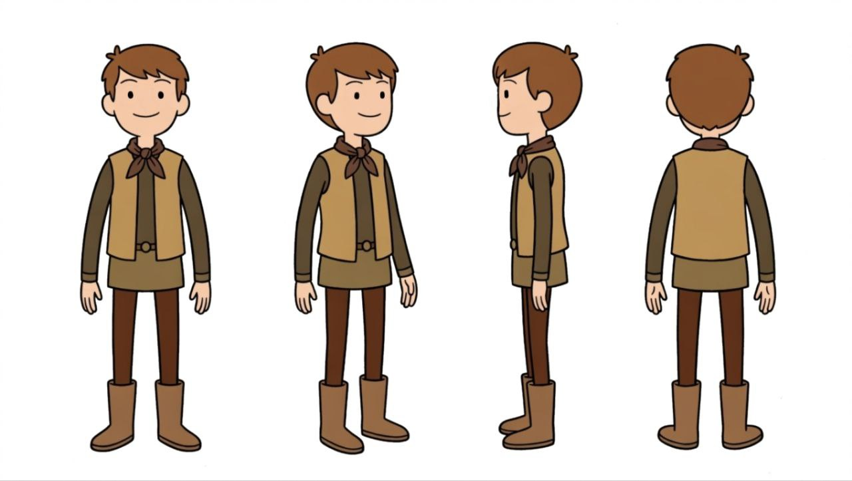
URIEN

QINN
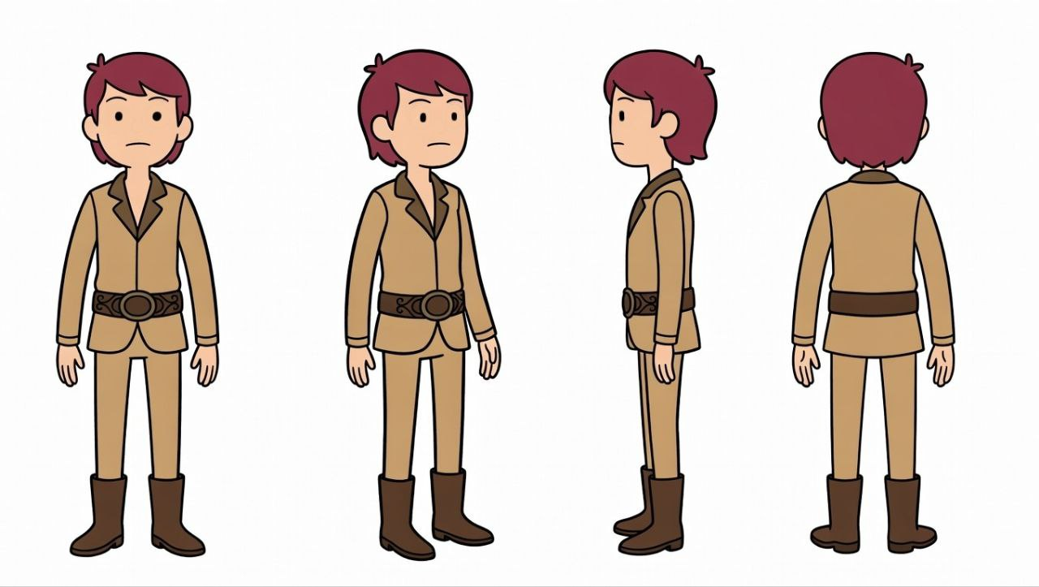

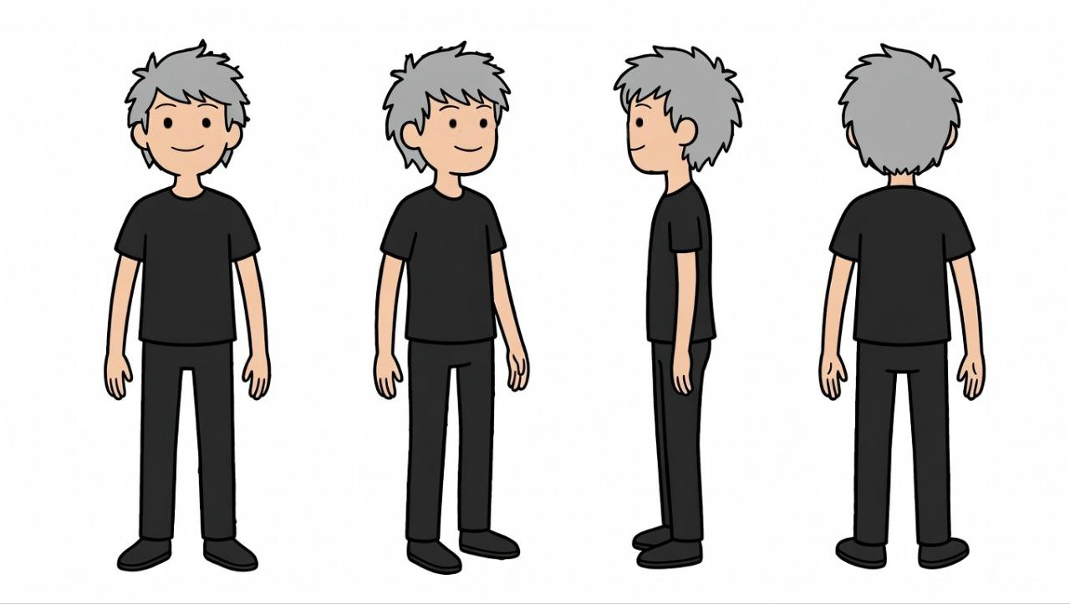
CREW 1 1

Description of Every Character

URIEN

Appearance:

Urien is a young adventurer with short, light brown hair and a calm expression. He wears a light brown tunic and darker brown pants, giving him a classic explorer look that blends practicality with humility.
Background:

Urien grew up near the coast, fascinated by tales of lost treasures and mysterious islands. His curiosity and determination led him to join an expedition in search of the legendary treasure.
Role in the Story:

Urien serves as the main protagonist and the more rational member of the duo. He often guides decisions during the journey by studying maps, analyzing clues, and thinking before acting. His leadership and calm nature balance Qinn’s impulsiveness.

Personality Traits:

- Brave but thoughtful.

- Empathetic.

- Curious.

- Moral compass.

QINN

Appearance:

Qinn has reddish-brown hair and a slightly taller build. His outfit is similar to Urien’s but features lighter tones, symbolizing his spirited and optimistic personality.
Background:

Qinn comes from a family of sailors and has always loved the sea. Though less experienced with maps and history than Urien, his heart and bravery make him a loyal partner in any challenge.
Role in the Story:

Qinn is the co-protagonist and Urien’s closest ally. He provides emotional warmth and a bit of comic relief during the tense moments of their adventure. His curiosity leads him to discover the glowing lamp at the end, triggering the story’s magical twist.

Personality Traits:

- Energetic and adventurous.

- Optimistic.

- Loyal.

- Naive but kind-hearted.

CREW MEMBER (Crew 1)

Appearance:

The crew member has gray hair and wears a plain black outfit, giving him a mysterious and slightly ominous aura. His design contrasts with Urien and Qinn’s lighter colors, hinting at his hidden motives.
Background:

Once a trusted member of the expedition, this crewman bears a secret greed. He joined the adventure not for exploration but for personal gain. When the shipwreck occurs, his ambition drives him to betray the others in pursuit of the treasure.
Role in the Story:
He is the antagonist who brings conflict to the narrative. His attempt to steal the treasure leads to the trap being triggered and the cave collapsing, symbolizing how greed leads to downfall.

Personality Traits:
- Secretive and cunning.
- Greedy.
- Cowardly.
- Tragic flaw: His greed ultimately causes his own demise.

Urien

Motivation: To uncover the truth behind the island’s legend and experience real adventure.
Relationship: Acts as Qinn’s guide and close friend, balances Qinn’s impulsiveness with logic.
Development: Learn that friendship and survival are more valuable than treasure.

Qinn

Motivation: Driven by excitement and the dream of finding treasure.
Relationship: Loyal companion to Urien and provides emotional warmth and humor.
Development: Realizes that true reward comes from home, safety, and shared experiences.

Crew Member

Motivation: Greed and desire for personal wealth.

Relationship: Distant and untrusting, betrays Urien and Qinn for his own gain.
Development: His greed leads to his downfall, showing the consequences of selfishness.

In "The Lost Island," the staging and composition choices are important in enhancing the storytelling and visual appeal of the animation. Here are some key considerations:
- Staging: Each scene is framed so the viewer’s eye is drawn to the most important element (e.g., Urien and Qinn on the beach, the lamp glowing in the sand). Clear layout and character placement, along with purposeful camera angles, help the story flow and keep focus on key moments.
- Composition: Visual balance, use of negative space, colour contrasts, and perspective create moods and highlight narrative moments.
- Timing & Rhythm: The pacing of movements, scene transitions, and camera cuts reflect emotional beats—slower moments in the jungle for discovery, faster cuts during the storm and trap collapse to guide viewer tension and release.
- Exaggeration: Actions, expressions, and camera moves are pushed beyond the purely realistic to amplify emotion and

clarity (e.g., a dramatic wave, a glowing lamp, the trap’s trigger). This enhances readability and makes visuals more memorable.
- Appeal: Characters, backgrounds, and motion carry charm and personality—via simple yet distinctive design, expressive poses, and colour choices—that engage viewers emotionally and make the story feel lively and accessible.

Layout Scenes
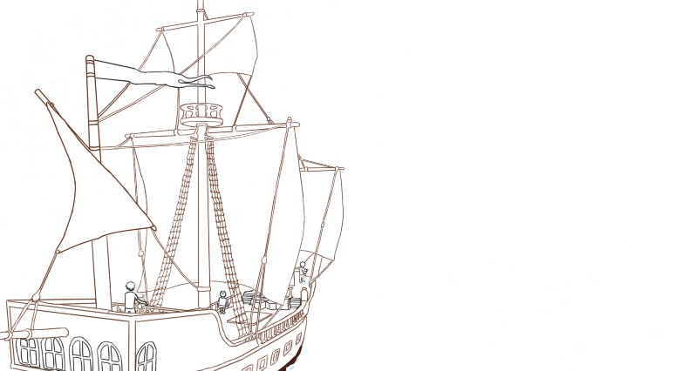
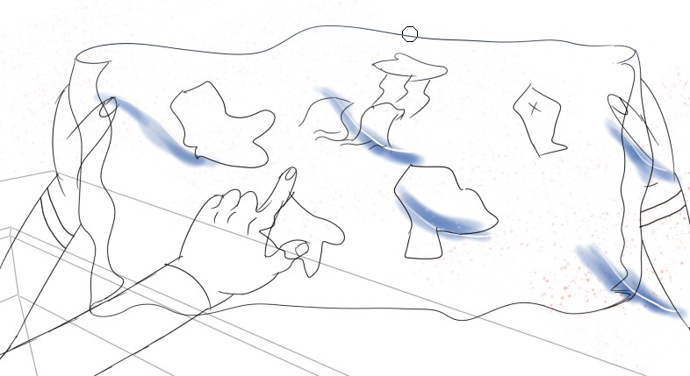
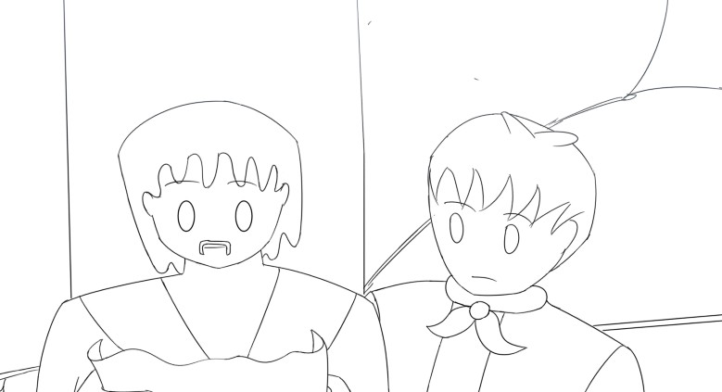
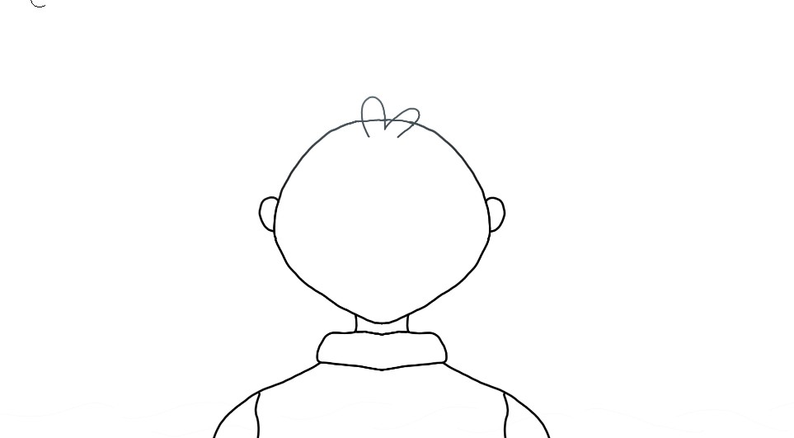
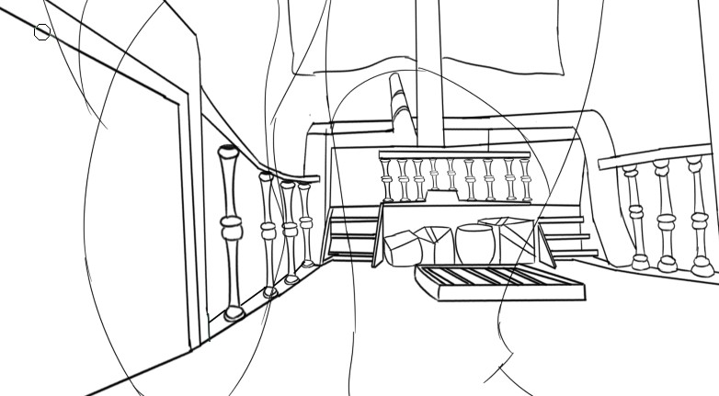

Camera Angle

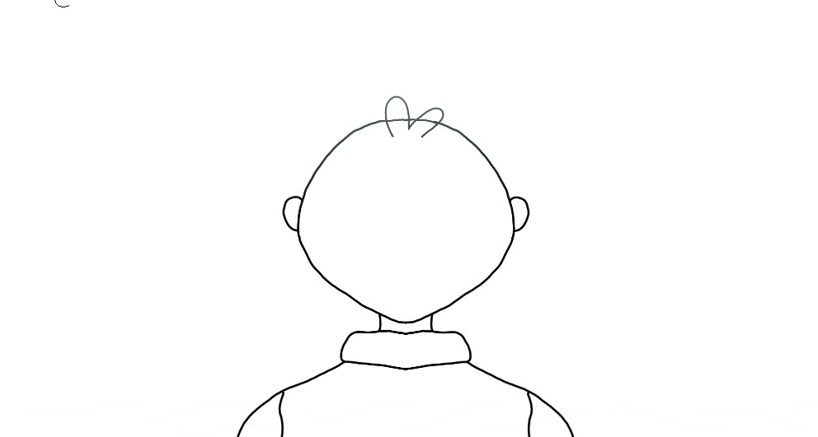

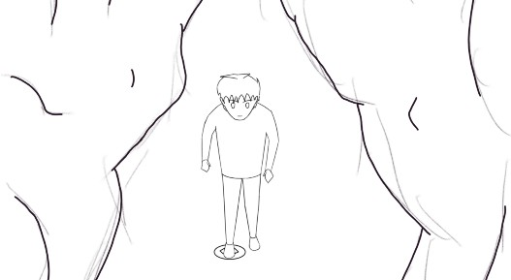
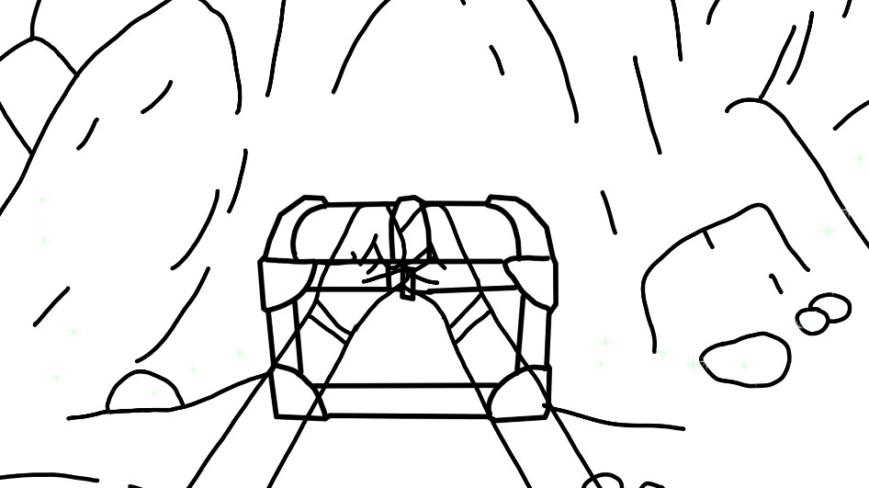

In between
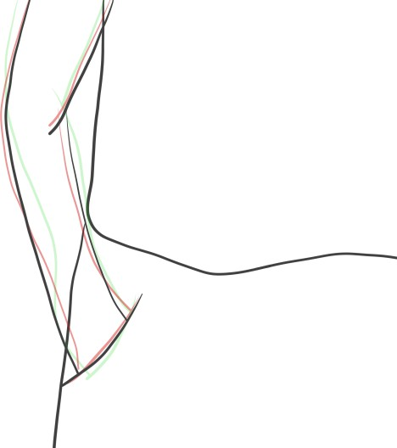
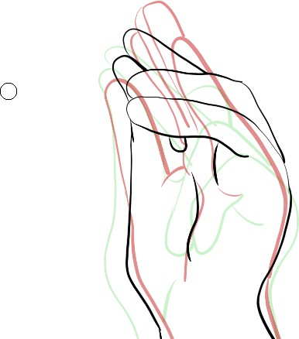

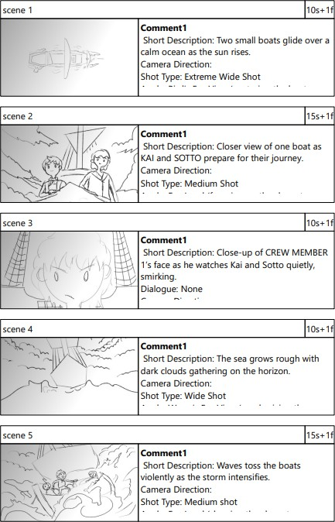
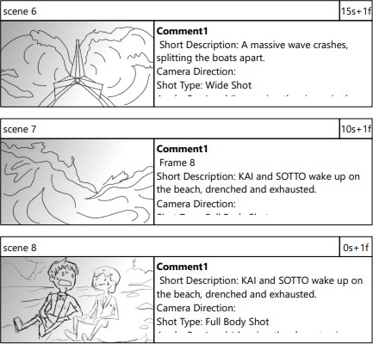
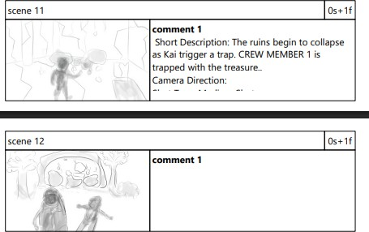
Storyboard

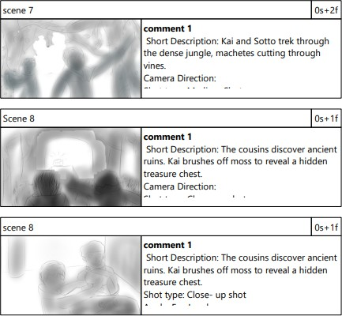

Clean-Up

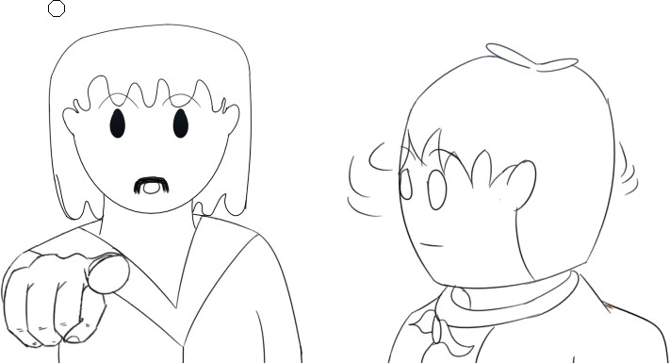
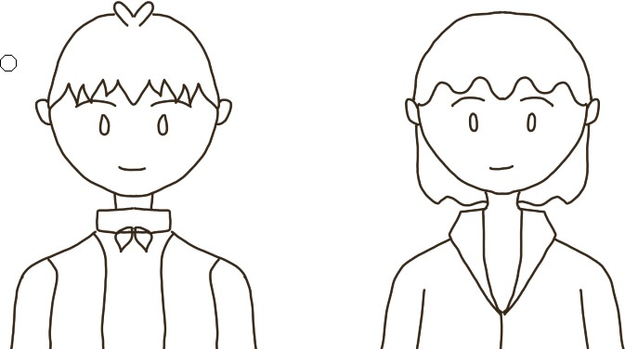

Background Scenes
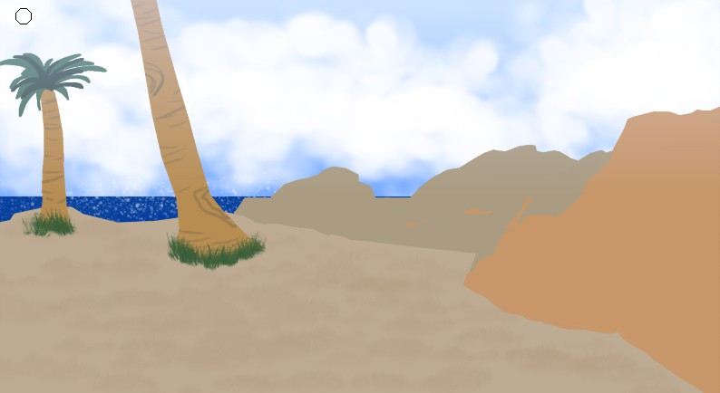
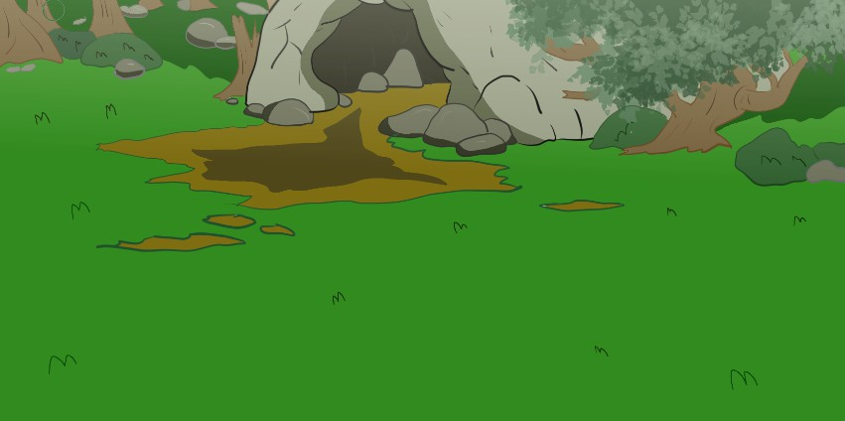

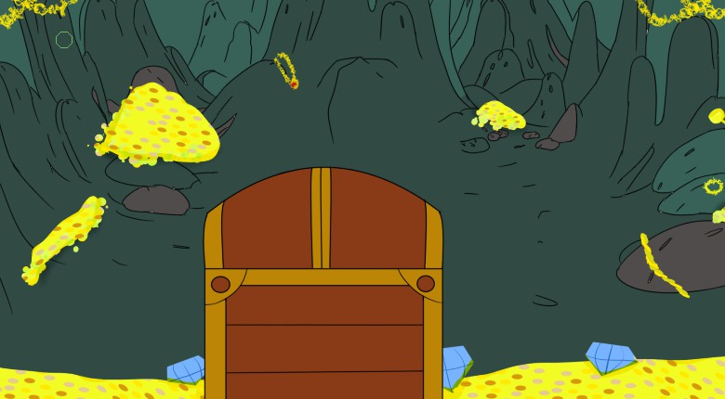

Post-Production, Challenges, and Target Audience

- Sound Design

The Lost Island uses ambient sounds, music, and effects to enhance mood, from the calm ocean to the intense storm and magical moments.
- Post-Production

Editing, color grading, and sound mixing were applied to ensure smooth transitions, consistent tone, and a polished final output.
- Production Challenges

The team faced time, skill, and animation consistency constraints, particularly in managing scene flow and effects. Despite these challenges, they overcame them through collaboration, continuous learning, and creative problem-solving to complete the project successfully.
- Target Audience

The target audience are young children, the animation’s adventurous theme, colorful visuals, and moral lessons make it both entertaining and meaningful.

Chapter V

Conclusion

In conclusion, The Lost Island portrays an exciting yet heartfelt story of survival, friendship, and the struggle between greed and morality. The journey of Urien and Qinn reflects how courage, and teamwork can overcome challenges. Audience survey results confirmed these themes were effectively communicated: most respondents rated the storyline as clear (54.5% gave the highest rating) and engaging (over 80% rated it 4 or 5). The sound design was also praised, with 91% finding it effective or very effective. While some noted animation delays and drawing style limitations, the majority expressed satisfaction, with 63.6% “satisfied” and 27.3% “very satisfied.”
This feedback shows that the project succeeded in delivering meaningful lessons about resilience and moral choice while maintaining entertainment value. It also highlights areas for improvement, particularly smoother animation timing and added visual details, which can guide future projects. Overall, The Lost Island demonstrates how storytelling in animation can be both educational and enjoyable, especially for children.

Summary

The Lost Island tells an exciting yet heartfelt story of survival, friendship, and the struggle between greed and morality. The journey of Urien and Qinn shows how courage and teamwork can overcome challenges, reminding audiences that true treasure lies not in gold but in relationships and resilience.

The animation was produced using a simplified Western art style inspired by Adventure Time, with vibrant colors and 2D digital techniques to enhance storytelling. Sound design and editing played an important role in setting the emotional rhythm, from calm ocean scenes to intense storms and magical moments.

Survey data confirmed that these creative choices resonated with viewers. A majority rated the storyline as clear and engaging, with over 80% giving high marks for clarity and emotional impact. Sound design was praised by 91% of respondents, while overall satisfaction reached 90% (satisfied or very satisfied). Constructive feedback highlighted areas for improvement, such as smoother animation timing, richer visual details, and potential character voice‑overs.

Despite challenges in time, skill, and technical consistency, the team overcame obstacles through collaboration and problem‑solving. The project not only strengthened animation and storytelling skills but also demonstrated how meaningful lessons about resilience, morality, and teamwork can be delivered in a way that is both educational and enjoyable for children.

Bibliography:

Karmakar, A. (2021). Investigation of artistic styles for effective storytelling in animation. NVEO: Natural Volatiles & Essential Oils, 8(3), pp.200–209.
Psychological Impact and Influence of Animation on Viewer’s Visual Attention. (2022). Journal of Electrical and Computer Engineering, 2022, pp.1–14.
Kılıç, E., & Yesiltaş, E. (2021). Effectiveness of values education with animations in social studies teaching.
International Online Journal of Educational Sciences, 13(5), pp.1370–1387.
Lazareva, A., & Cruz-Martinez, G. (2020). Digital storytelling project as a way to engage students in twenty-first century skills learning. International Studies Perspectives, 22(4), pp.383–406.
Jiménez, R. G.-A., & Martínez, M. V. d. M. (2024). Fostering civic values through short animations: A didactic resource for elementary students. Arts & Communication, 2(3), p.2806.
Çelik, H., & Yılmaz, H. B. (2021). Effectiveness of values education with animations in social studies teaching.
International Online Journal of Educational Sciences, 13(5), 1370–1387. Retrieved from https://www.researchgate.net/publication/356695453
Kumar, P., Yadav, L. K., & Goel, P. (2022). Psychological Impact and Influence of Animation on Viewer's Visual Attention and Cognition: A Systematic Literature Review, Open Challenges, and Future Research Directions. Psychology Research and Behavior Management, 15, pp.2459–2479.
Connolly, M. (2025). Animation as a Teaching Tool: Enhancing Educational Outcomes. Educational Voice. Retrieved from https://educationalvoice.co.uk/aanimation-as-a-teaching-tool/

Appendix A.
Evaluation of The Lost Island

- Overall Animation Quality

Question Type: Linear scale
Scale: 1 (Very Poor) — 5 (Excellent)

- Storyline Clarity

Question Type: Linear scale
Scale: 1 (Very unclear) — 5 (Very clear)

- Character Appeal

Question Type: Linear scale
Scale: 1 (Not appealing) — 5 (Very appealing)

- Story Engagement

Question Type: Linear scale
Scale: 1 (Not engaging) — 5 (Highly engaging)

- Sound Design Effectiveness

Question Type: Linear scale
Scale: 1 (Not effective) — 5 (Very effective)

- Emotional Impact

Question Type: Linear scale
Scale: 1 (No impact) — 5 (Strong impact)

- Recommendation Likelihood

Question Type: Multiple choice
Options:

Very unlikely

Unlikely

Neutral

Likely

Very likely

- Most Engaging Aspect

Question Type: Multiple choice
Options:

Animation quality

Storyline

Characters

Sound design

Other: _______

- Character Design Relevance

Question Type: Linear scale
Scale: 1 (Not matched) — 5 (Perfectly matched)

- Overall Satisfaction

Question Type: Linear scale
Scale: 1 (Very dissatisfied) — 5 (Very satisfied)

- Comments or Suggestions

Question Type: Sentence
Question:
Please share any comments or suggestions to improve The Lost Island.

Appendix B.
Survey response

1-(Very Poor) 5-(Excellent)
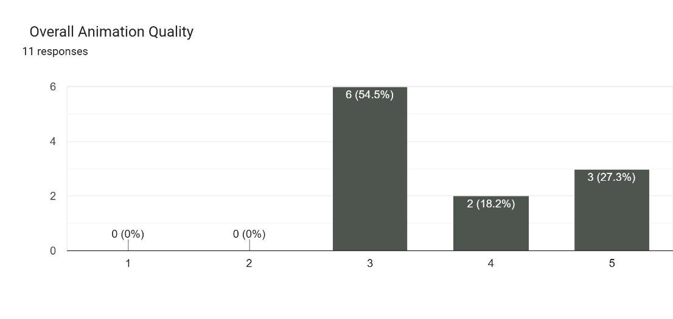

1-(Very Unclear) 5-Very Clear)
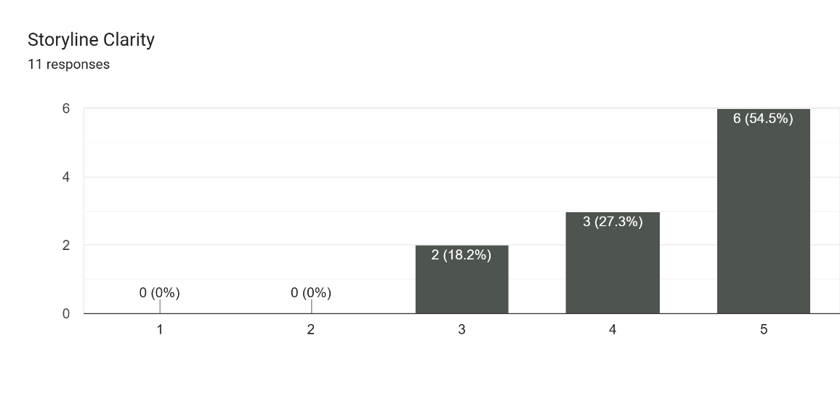

1-(Not Appealing) 5- (Very Appealing)
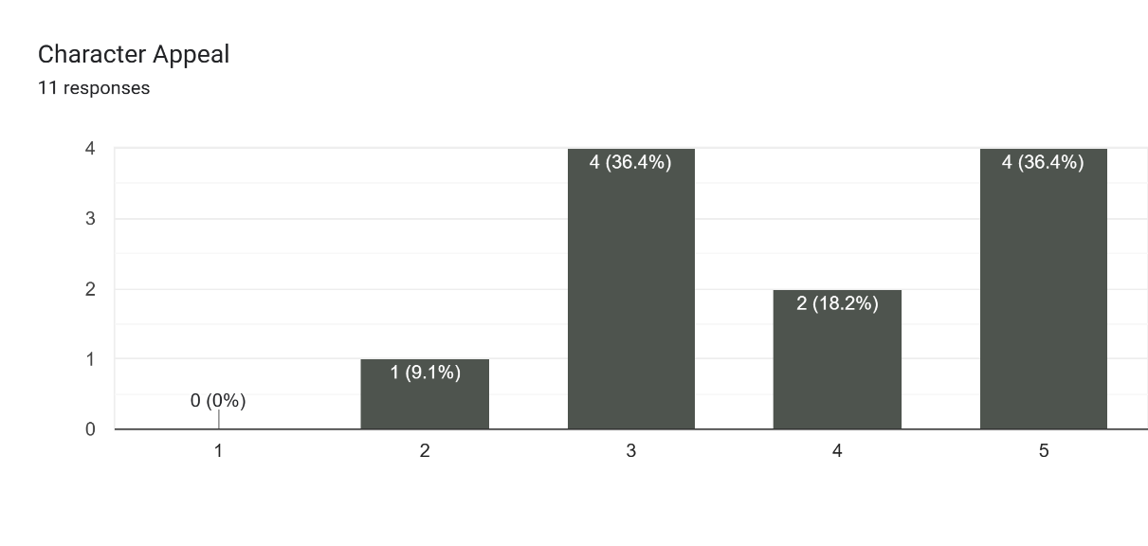
1-(Not engaging) 2- (Not engaging)
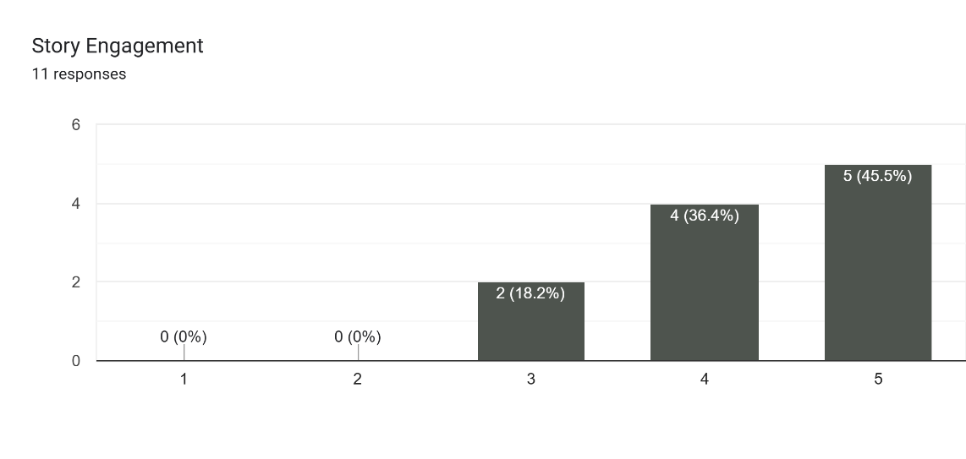
1-(Not Effective) 2- (Very effective)
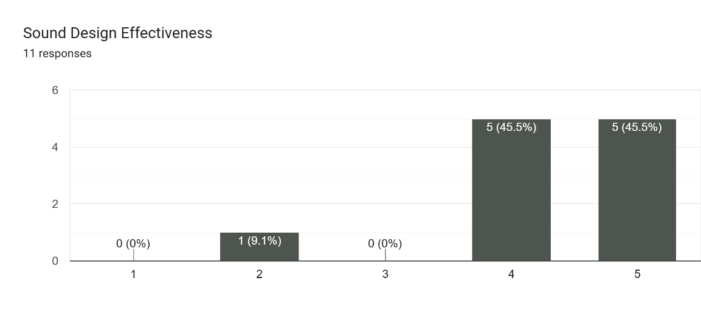

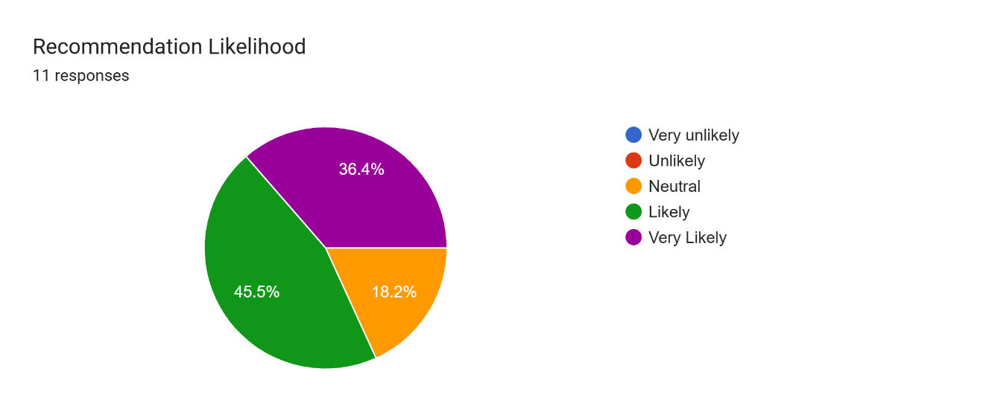
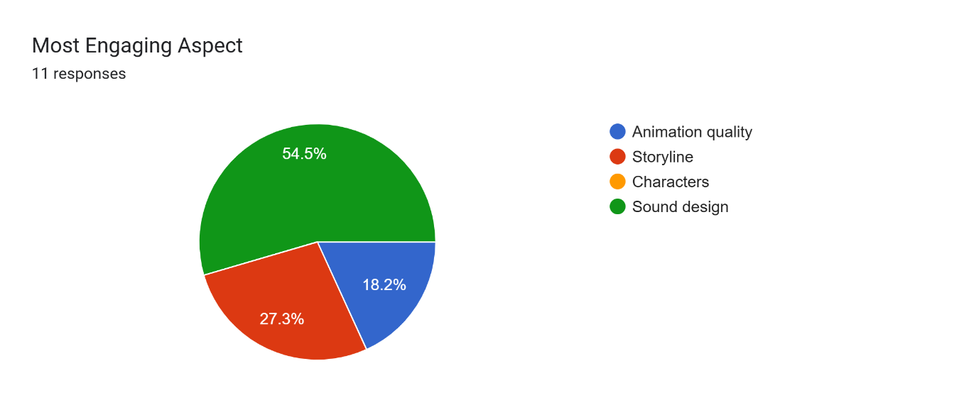
1-(Very dissatisfied) 2- (Very satisfied)

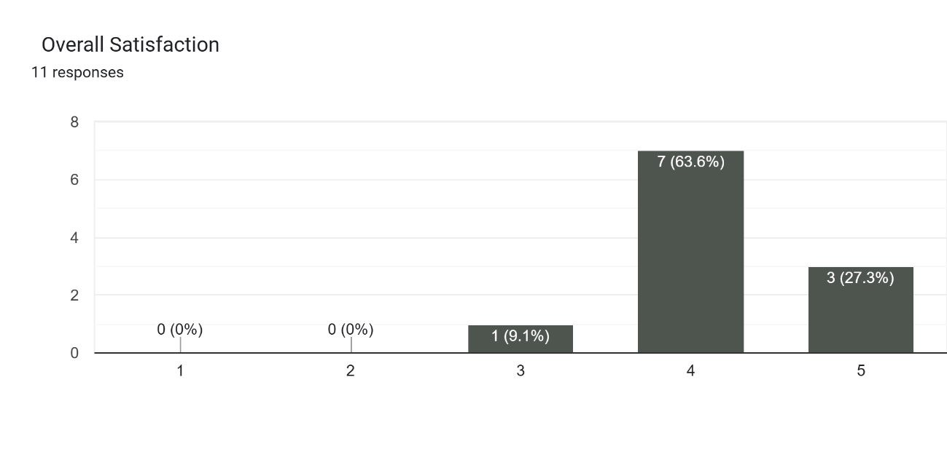

Comments or Suggestions:

Respondents praised the storyline and sound effects, noting the animation was engaging and enjoyable for children. At the same time, they pointed out areas for improvement, such as smoother animation timing, better synchronization with sound effects, enhanced drawing quality, Suggestions also included adding more background details and considering character voice-overs to make the film livelier and immersive. Overall, the feedback confirmed the project’s strengths while offering clear guidance for refining future work.

Curriculum Vitae
